**HEALTH MONITORING FOR COMATOSE PATIENT**

**USING IOT**

**A PROJECT REPORT**

***Submitted by***

**SANTHIYA P 710021106317**

**ABINAYA SARASWATHI S 710021106316**

**PRITHIKA K 710021106701**

***In partial fulfillment for the award of the degree***

***of***

**BACHELOR OFENGINEERING**

***in***

**ELECTRONICSANDCOMMUNICATIONENGINEERING**

**ANNAUNIVERSITYREGIONALCAMPUS, COIMBATORE**

**ANNA UNIVERSITY : CHENNAI–600025**

**NOVEMBER 2023**

**ANNA UNIVERSITY, CHENNAI**

**BONAFIDE CERTIFICATE**

Project report titled **“HEALTH MONITORING FOR COMATOSE PATIENT”** is the bonafide work of**“SANTHIYA P(710021106317), ABINAYASARASWATHI S(710021106316) ,PRITHIKA K (710021106701)”**who carried out the project work under my supervision

Dr.V.R.Vijaykumar M.E, Ph.D., Dr.P.Seethalakshmi M.E,Ph.D.,

Head of the Department, Supervisor,

Associate Professor, Associate Professor,

Department of ECE, Department of ECE,

Anna University Regional Campus, Anna University Regional Campus,

Coimbatore – 641 046. Coimbatore – 641 046.

**ACKNOWLEDGEMENT**

**ACKNOWLEDGEMENT**

First and foremost, we place this project work on the feet of **GOD ALMIGHTY** who is the power of strength in each step of progress towards the successful completion of the project.

We owe whole hearted sense of reverence and gratitude to our Guide,

**Ms. S. Manju M.E,** for her efficient and excellent guidance, inspiring discussions insightful and timely encouragements for the successful completion of the project.

I thank **Dr.M. SARAVANAKUMAR MBA., Ph.D.,** Dean Regional Campus, Anna University Regional Campus, Coimbatore for his great support with blessings. I also extend my heartfelt thanks to all Faculties and staff of ECE department who have rendered their valuable help in making this project successful.

**SANTHIYA P** - **710021106317**

**ABINAYA SARASWATHI S** - **710021106316**

**PRITHIKA K** - **710021106701**

**ABSTRACT**

Coma is a state of unconsciousness where the patient fails to respond. These patients need utmost care and 24*7 observations. This paper presents a continuous monitoring and recording of patient data without human intervention. If there is any sudden changes occur in the normal range of body parameters such as body temp falls or rise, blood pressure (B. P.) increases or decreases causing high or low B.P. where both are not stable conditions for better health, then it has facility to automatically alert the medical person. The development sensor identifies the patient development and furthermore produces an alarm message to the clinical individual.

|  |  |  |
| --- | --- | --- |
|  | **TABLE OF CONTENTS** | |
| **SNO** | **CONTENT** |  | |
|  | ACKNOWLEDGEMENT | 3 | |
|  | ABSTRACT | 4 | |
|  | TABLE OF CONTENTS | 5 | |
|  | LIST OF FIGURES | 6 | |
|  | **INTRODUCTION** | 9 | |
| 1.1 | PROBLEM STATEMENT | 9 | |
| 1.2 | OBJECTIVE | 10 | |
| 1.3 | CHAPTER ORGANIZATION | 10 | |
| **CHAPTER_2** | **LITERATURE SURVEY** | 11 | |
|  | INTRODUCTION | 11 | |
| 2.1 | IOT HEALTH CARE | 11 | |
| 2.2 | ADVANTAGE | 13 | |
| **CHAPTER_3** | **EXISTING SYSTEM** | 13 | |
|  | INTRODUCTION | 13 | |
| 3.1 | HOW TO CARE COMA PATIENT | 13 | |
| 3.2 | ADVANTAGE | 15 | |
| **CHAPTER_4** | **PROPOSED SYSTEM** | 16 | |
|  | INTRODUCTION | 16 | |
| 4.1 | METHODOLOGY | 16 | |
| 4.2 | ADVANTAGE | 17 | |
| 4.3 | BLOCK DIAGRAM | 17 | |
| 4.4 | WORK FLOW | 18 | |
| 4.5 | THE HARDWARE DIAGRAM INCLUDE | 18 | |
| 4.6 | HARDWARE REQUIREMENT | 19 | |
| 1. | PULSE SENSOR | 19 | |
| 2. | TEMPERATURE SENSOR | 20 | |
| 3. | ULTRASONIC SENSOR | 21 | |
| 4. | EYEBLINK SESNOR | 23 | |
| 5. | HCO5 BLUETOOTH | 24 | |
| 6. | BREAD BOARD | 25 | |
| 7. | LCD DISPLAY | 27 | |
| 4.7 | HARDWARE IMPLEMENTATION | 27 | |
| 4.8 | SOFTWARE REQUIREMENT | 28 | |
| 4.9 | SOURCE CODE | 30 | |
| 4.10 | RESULT AND DISCUSSION | 34 | |
|  | CONCLUSION | 35 | |
|  | REFERENCE | 36 | |

**LIST OF FIGURES**

**FIGURE TITLE PAGE**

**NO NO.**

1.1 INTRODUCTION 9

2.1 IOT IN HEALTH CARE 11

3.1 HOW TO CARE COMA PATIENT 13

4.1 METHODOLOGY 16

4.3 WORK FLOW 18

4.6 HARDWARE REQUIREMENTS 19

4.7 HARDWARE IMPLEMENTATION 27

4.8 SOFTWARE REQUIREMENT 28

4.10 RESULTS AND DISCUSSION 34

**INTRODUCTION**

* Patients who are comatose are unconscious and unable to react to their surroundings. This can happen for a number of causes, including serious infection, traumatic brain injury, stroke, drug overdose, and stroke. patients in a comatose state need to have their vital signs continuously monitored.
* The IoT-based monitoring system makes use of a number of sensors, including eye blink sensor , temperature, and pulse sensors, to gather and send data to a central server over a wireless network. To find patterns and trends in the patient's condition. The device also has an alarm system that goes out when it detects a critical change in the patient's vital signs
* Sensors, a gateway, and a central server are typically the three essential parts of the system design. The sensors are responsible for gathering the patient's vital signs and are attached to the patient's body. By serving as a middleman between the sensors and the main server, the gateway transmits the data gathered by the sensors to the server. The collected data must be stored, analyzed, and, if necessary, an alert must be generated by the central server.

**1.2 PROBLEM STATEMENT**

The main goal of our project is to create a device which will ease the required efforts of a medical personnel to monitor a comatose patient. The device will be a boon to medical authorities and will help the family members not only to have an access to convenient and efficient updates about the improvement but also will notify any emergencies about the concerned. The device will keep track of accurate measurements, movements and progress of the concerned.

**1.4 OBJECTIVE**

An IoT-based monitoring system for comatose patients should be able to continuously and remotely monitor vital signs to enhance the standard of care and enable the early identification of any health concerns.

**1.5 CHAPTER ORGANIZATION**

**Chapter 2 :**Deals with existing system that some authors have already did for health monitoring for comatose patient.

**Chapter 3 :**Deals with the existing technology that has been created to some sensors only used for monitor comatose patient.

**Chapter 4** : Deals with proposed methodology that has been created to overcome the existing technology to improve the updated data and safety of patient. Explains the various sensors and their types used in the patient body. Deals the result and discussion about the project.

**Chapter 5**: Concludes with contribution made in the report.

**CHAPTER 2**

**LITERATURE SURVEY**

**INTRODUCTION**

Patients who are comatose are unconscious and unable to react to their surroundings. This can happen for a number of causes, including serious infection, traumatic brain injury, stroke, drug overdose, and stroke. In order to spot any changes in their condition that could point to a lifethreatening circumstance, patients in a comatose state need to have their vital signs continuously monitored. The likelihood of survival and recovery for the patient can be considerably increased with prompt detection and treatment. It can be time-consuming and prone to human error for medical workers to manually check the patient's vital signs at regular intervals with traditional monitoring devices. However, new monitoring systems have been created as a result of technological breakthroughs that can offer real-time monitoring and analysis of the patient's vital signs. One such technology approach is the IoT (Internet of Things)-based monitoring system for patients who are unconscious.

**PREVIOUS WORKS**

A person who is unconscious and unable to speak is said to be in a coma. These people need the highest care and ongoing supervision. This study demonstrates the continuous monitoring and recording of patient data without human involvement. If any sudden changes in the typical range of physiological parameters occur, such as a dip or rise in body temperature or a spike in Blood Pressure (B.P.), which are not stable conditions for better health, it has the capacity to promptly alert a medical professional. The movement sensor picks up the patient's movement and notifies the medical staff if something is amiss. The majority of older persons nowadays get heart failure as a result of their inability to detect their current heart rate while they are awake or performing other tasks. To find diseases like COVID-19, remote body temperature monitoring is required, even in rural areas. To address the flaws in the current healthcare system, these organizations deploy IoT technologies. This research study covers a health monitoring system that is IOT-based and enables us to track a patient's body temperature, humidity, and pulse rate. Such a system has been designed due to its importance in doing a regular check on the patient's health in the event of casualties, which are highly common in this COVID pandemic situation. Monitoring coma sufferers' health requires the Internet of Things (IoT). Continuous fitness monitoring can save up to 60% of human lives by timely detection. The apparatus is designed exclusively for real-time tracking of coma patients' vital signs. It is now more appropriate to determine the patient's health or condition thanks to the use of GSM and IoT. This proposed method uses a number of smart sensors, including temperature, heartbeat, eye blink, and SPO2 (peripheral capillary oxygen saturation) sensors, to measure the patient's body temperature, coronary heart rate, eye movement, and oxygen saturation percentage. This system uses an Arduino-UNO board as a microcontroller and the cloud computing idea.

**IOT IN HEALTH CARE**

The intersection of healthcare and technology has witnessed an extraordinary evolution, chiefly due to the integration of the Internet of Things (IoT). A multitude of research articles have delved into this realm, exploring the expansive landscape of IoT applications in healthcare, its challenges, opportunities, and the potential it holds for revolutionizing patient care.

One focal point is the utilization of IoT in remote health monitoring, a paradigm explored in multiple studies. "Remote Health Monitoring Using Mobile Phones and Web Services" (IEEE Transactions on Biomedical Engineering, 2012) emphasizes the pivotal role of mobile devices and web services in chronic disease management. The integration of these technologies facilitates remote monitoring, offering patients continuous healthcare support and personalized interventions.

Moreover, wearable devices have emerged as a significant facet of health monitoring. "Wearable Health Devices—Vital Sign Monitoring, Systems and Technologies" (Sensors, 2018) discusses the integration of sensors into wearable devices and their interconnectedness with IoT. These devices have the potential to collect real-time data on vital signs, enabling proactive healthcare interventions and personalized treatment plans.

However, while the amalgamation of IoT and healthcare presents immense potential, it also brings forth a set of challenges. "Security and Privacy Issues in Wireless Sensor Networks for Healthcare Applications" (Journal of Medical Systems, 2015) sheds light on the criticality of safeguarding sensitive patient data. Data security and privacy concerns loom large, necessitating robust measures to protect patient information from unauthorized access and breaches.

Furthermore, interoperability emerges as a significant hurdle in the effective implementation of IoT in healthcare. "A Survey on Interoperability and Security in Healthcare IoT" (IEEE Internet of Things Journal, 2019) elucidates the challenges associated with the compatibility of diverse IoT devices and stresses the urgent need for standardized protocols to ensure seamless communication and data exchange.

In parallel, the advent of machine learning (ML) in healthcare IoT heralds a new era of data analysis and decision-making. "A Review on Internet of Things (IoT) in Health Care and Remote Medical Monitoring" (Archives of Computational Methods in Engineering, 2019) explores the potential of ML algorithms in analyzing data collected by IoT devices. ML holds promise in deciphering intricate health patterns, aiding in diagnosis, treatment optimization, and personalized patient care.

Furthermore, the profound impact of IoT on chronic disease management has been a focus of extensive research. "Internet of Things (IoT) for Automated and Remote Management of Chronic Disease: A Review" (Healthcare, 2018) delineates how IoT-based approaches can automate and remotely manage chronic diseases. This paradigm shift in healthcare delivery holds immense promise in enhancing patient outcomes and reducing healthcare costs.

Real-time health monitoring systems have also garnered attention for their potential in revolutionizing patient care. "Real-time Health Monitoring Systems: A Comprehensive Review" (Journal of Ambient Intelligence and Humanized Computing, 2020) provides insights into the architecture, sensors, data processing, and analytics capabilities of these systems. Their ability to offer instantaneous insights into a patient's health status enables timely interventions and proactive healthcare management.

Collectively, these research articles paint a comprehensive picture of the multifaceted landscape of IoT in healthcare. They underscore the potential of IoT applications in revolutionizing healthcare delivery, from remote patient monitoring to real-time analytics, chronic disease management, and personalized interventions.

However, they also emphasize the critical challenges that must be addressed, such as data security, interoperability issues, and the ethical implications of handling sensitive patient information. Overcoming these challenges will be pivotal in harnessing the full potential of IoT in healthcare and ushering in an era of patient-centric, data-driven, and proactive healthcare delivery.

**SUMMARY**

The amalgamation of IoT and healthcare stands as a beacon of innovation, promising a future where technology not only augments medical care but fundamentally transforms the way healthcare is delivered, making it more accessible, efficient, and personalized.

**CHAPTER 3**

**EXISTING SYSTEM**

**INTRODUCTION**

The care and management of a patient in a coma involve a multidisciplinary approach, typically coordinated by healthcare professionals such as neurologists, intensivists, nurses, and other specialists. The specific details of the existing system for coma patients may vary depending on the healthcare facility and the patient's condition. However, here are some general aspects of the existing system for managing coma patients

**CHAPTER 4**

**PROPOSED SYSTEM**

**INTRODUCTION**

A health observing system comprises of variety of sensors connected to the patient and they communicate that data via the processing Thinkspeak. In this project, Node MCU is acts as a data junction node as well as a processor. The patient and doctor smart phone or computers are used as a monitoring device. The sensors are used to measure the health parameters of patient after these parameters are acts as readings and finally converted into signals. These signals are provided for processing to Node MCU. Then Node MCU displays the information on a monitor and also stores the information over the cloud with the help of IoT. This information can be accessed by the doctor on his phone/computer and get the notification. Also there is facility provided to send an alert message to the doctor or patient care giver if any abnormal data is detected. The workflow of the project is as- the sensors value are read and displayed on the monitor and stored in the cloud for future use.

**4.1 METHODOLGY**

The proposed health monitoring system consists of different sensors which are divided into two categories. One is used for monitoring vitals of the comatose and second is used for detecting any physical changes occur in the comatose. Here, temperature and blood pressure are the two vitals recorded and monitored to understand health status of a comatose. The other two sensors are MEMS accelerometer sensor and Eye blink sensor which are used for detecting any physical changes that occurring comatose. These sign switch gives data are recorded and checked consistently to comprehend the body working. In the event that the arrangements of these detected signs which areoutside ordinary rangesnormally suggest the requirement for some consideration or conceivable departure to a more elevated level of treatment during which we alert the doctor.

**4.3 BLOCK DIAGRAM**

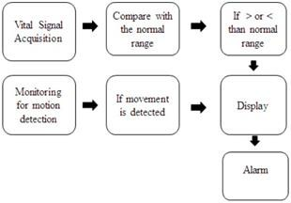

**4.4 WORK FLOW**

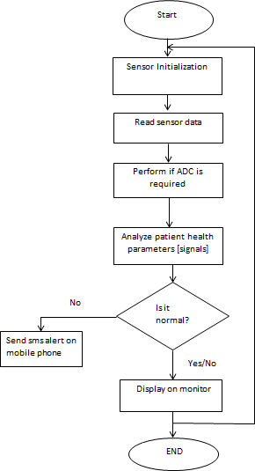

**SUMMARY**

The system is designed to display this data at regular intervals and process it, potentially conducting clinical tests based on the received information. This setup involves a network of sensors connected to an Arduino Uno, which serves as a bridge to transmit the collected health data to an IoT server. The system aims to monitor and analyze various vital signs and physiological parameters of a patient, providing real-time insights that could potentially aid in clinical assessments and ongoing health monitoring.

**CHAPTER 5**

**HARDWARE REQUIREMENT**

**COMPONENTS REQUIRED**

* IR Sensor
* ULTRA SONIC sensor
* LCD Module (To print the Sensor output)
* TEMPERATURE sensor
* PULSE sensor
* EYE BLINK sensor

1. **PULSE SENSOR**

A gadget used to detect heart rate or pulse rate is called a pulse sensor. It is a non-invasive gadget that uses light-based technology to track blood flow through skin capillaries. The most popular kind of pulse sensor is the photoplethysmography (PPG) sensor, which measures the amount of blood in the skin using a light source and a detector.

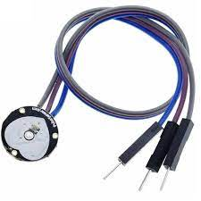

Pulse sensors are frequently employed in many different fields, including as medicine, physical fitness, and consumer electronics. Here are a few of the most typical applications for pulse sensors:

1) Applications in medicine: In order to keep track of patients' heart rates during surgery or in intensive care units, pulse sensors are frequently employed in medical settings. Arrhythmias or irregular heartbeats can also be found using them.

2) Application in fitness: Fitness trackers and smartwatches frequently use pulse sensors to track a user's heart rate while they are working out. The user's degree of fitness can be determined by using this data to monitor the workout's intensity.

3) Consumer electronics: The usage of pulse sensors in consumer electronics, such as smartphones and headphones, is growing. These devices give users access to biometric information. As an illustration, several modern smartphones come equipped with in-built pulse sensors that let users check their heart rate remotely.

In general, pulse sensors are adaptable tools that can offer insightful data on the body's circulatory system. They can assist people in keeping track of their health and fitness and are utilised in a variety of contexts.

**2.TEMPERATURE SENSOR**

Digital temperature sensors like the DS18B20 can monitor temperatures with an accuracy of up to 0.5°C. It is a wellliked sensor since it is easy to use, inexpensive, and compatible with microcontrollers and other electrical equipment.

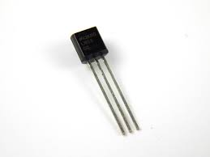

The DS18B20 temperature sensor can be used in the following applications:

1) Home automation: The DS18B20 can be used to track the temperature in different areas of a home and regulate the heating or cooling systems as necessary.

2) Automation in the industrial setting: The sensor can be used to check the temperature of machinery like transformers, motors, and generators. 3) Agriculture: The sensor can be used to regulate the heating and ventilation systems as well as to monitor and manage the temperature in greenhouses and animal enclosures.

4) Meteorological monitoring: The sensor can be paired with other sensors to detect humidity, air pressure, and other meteorological parameters. It can be used in weather stations to measure outdoor temperature.

5) Medical equipment: The sensor can be used to monitor and regulate temperature in medical equipment like incubators and refrigerators.

The DS18B20 temperature sensor, in general, is a flexible and dependable device for detecting temperature in a variety of applications.

**3.ULTRASONIC SENSOR**

An electrical sensor known as an Ultrasonic Sensor uses sound waves to detect objects and measure distances. It operates on the same echolocation principle that dolphins and bats use to navigate and find objects. High-frequency sound waves are emitted by ultrasonic sensors, which are reflected back to the sensor after hitting an object. The distance to an item is calculated using the time it takes for the sound wave to go there and back.

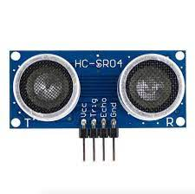

Numerous industries, such as robotics, home automation, automotive, and industrial automation, use ultrasonic sensors.

The following are a few examples of projects that can be made with an ultrasonic sensor:

1) Robot that avoids obstacles: Ultrasonic sensors can be used to identify objects in a robot's path and prevent collisions.

2) Distance Measuring: Ultrasonic sensors can be utilised in industrial applications such as parking sensors, level measurement, and distance measurement to measure the distances between objects.

3) Liquid Level Detection: In industrial settings, ultrasonic sensors can be used to gauge the liquid level in tanks or other containers.

4) Smart Home Automation: When a person enters a room, ultrasonic sensors can detect their presence and change the temperature and lighting accordingly.

5) Autonomous Vehicles: To find barriers and other vehicles on the road, self-driving cars can employ ultrasonic sensors.

When non-contact sensing is needed, ultrasonic sensors are chosen above other types of sensors. They are also preferable in circumstances where abrasive elements like dust, smoke, or fog might impair the ability of other types of sensors to sense.

**4. EYE BLINK SENSOR**

A PIR motion sensor (passive infrared) is an electrical sensor that detects motion by detecting the heat radiated by moving objects or living things. The sensor consists of a circuit that amplifies and analyses the signal as well as a pyroelectric sensor that detects changes in infrared radiation. The linked device or microcontroller receives a signal from the sensor when motion is detected.

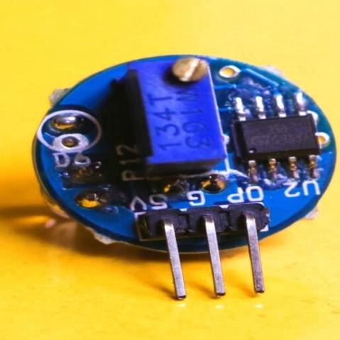

PIR motion sensors are frequently employed in home automation, security systems, and lighting control. A PIR motion sensor can be used in a variety of tasks, for instance:

1) Security system: Intruders can be discovered and an alarm or alert system can be activated using PIR motion sensors.

2) Lighting Control: PIR motion sensors can be used to programme lights to come on when someone enters a room and go off when no one is there. 3) Home automation systems, such as those that turn on the air conditioning when someone enters a room, can be activated by PIR motion sensors.

4) Wildlife Monitoring: PIR motion sensors can be used to detect animal presence and activate cameras or other recording equipment in wildlife monitoring systems.

5) Energy Conservation: When no one is present in a room, PIR motion sensors can be utilised to save energy by shutting off lights and other appliances.

When non-contact sensing is needed and the movement is sluggish or the range is constrained, PIR motion sensors are favoured over other types of motion sensors. They are also preferable in circumstances where abrasive elements like dust, smoke, or fog might impair the ability of other types of sensors to sense.

# **5. HC-05 Bluetooth Module**

* HC-05 is a Bluetooth module which is designed for wireless communication. This module can be used in a master or slave configuration.

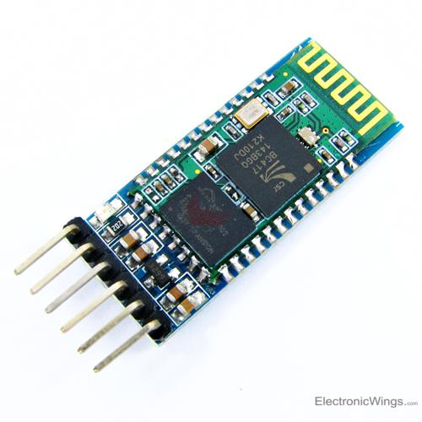

# **HC-05 Bluetooth Module Pin Diagram**

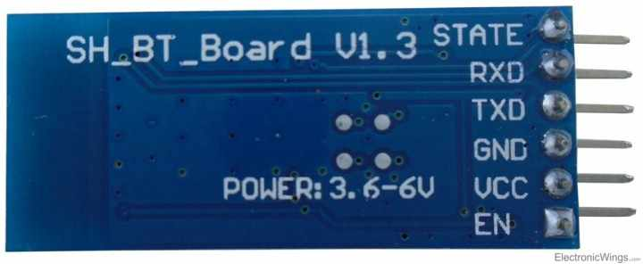

**HC-05 Bluetooth Module Pin Diagram**

Bluetooth serial modules allow all serial enabled devices to communicate with each other using Bluetooth.

It has 6 pins,

1.  **Key/EN:** It is used to bring Bluetooth module in AT commands mode. If Key/EN pin is set to high, then this module will work in command mode. Otherwise by default it is in data mode. The default baud rate of HC-05 in command mode is 38400bps and 9600 in data mode.

HC-05 module has two modes,

 1.  **Data mode:**Exchange of data between devices.

 2.  **Command mode:**It uses AT commands which are used to change setting of HC-05. To send these commands to module serial (USART) port is used.

3.  **VCC:**Connect 5 V or 3.3 V to this Pin.

4.  **GND:**Ground Pin of module.

5.  **TXD:**Transmit Serial data (wirelessly received data by Bluetooth module transmitted out serially on TXD pin)

6.  **RXD:** Receive data serially (received data will be transmitted wirelessly by Bluetooth module).

7.  **State:**It tells whether module is connected or not.

**HC-05 module Information**

* HC-05 has **red LED** which indicates **connection status**, whether the Bluetooth is connected or not. Before connecting to HC-05 module this red LED blinks continuously in a periodic manner. When it gets connected to any other Bluetooth device, its blinking slows down to two seconds.
* This module **works on 3.3V**. We can connect 5V supply voltage as well since the module has on board 5 to 3.3 V regulator.
* As HC-05 Bluetooth module has **3.3V level for RX/TX** and microcontroller can detect 3.3 V level, so, no need to shift transmit level of HC-05 module. But we need to shift the transmit voltage level from microcontroller to RX of HC-05 module.
* The data transfer rate of HC-05 module can vary up to **1Mbps** is in the **range of 10 meters**.

**6. BREAD BOARD**

A reusable solderless tool called a breadboard is used to prototype electronic circuits. It is essentially a board with a network of interconnected sockets and holes that make it simple to plug in and out of electronic components without the use of solder.

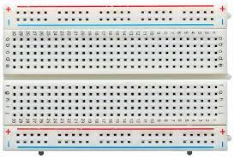

The fundamental benefit of utilising a breadboard is that it enables quick and simple electronic circuit prototyping without requiring any specialised tools or equipment. Due to this, it is the perfect tool for professionals, students, and hobbyists that need to quickly test and iterate on their concepts.

A breadboard is frequently used for the following purposes:

1) Circuit prototyping and testing: Designers may quickly test out various parts and setups to discover what functions best by using breadboards, which are frequently used for this purpose.

2) For educational purposes, breadboards are also used to introduce students to the fundamentals of electronics and circuit design in classroom settings.

3) Circuit design: Prior to being constructed on a PCB, more sophisticated circuits can be designed and tested on breadboards. (Printed circuit board).

4) Circuit debugging: Designers can quickly locate and resolve any problems by using breadboards for circuit debugging.

The PCB of this electronic circuit has a potentiometer. That potentiometer lets users adjust the detection range. The sensor has a very good and stable response even in ambient light or in complete darkness.

**7.LCD Display**

An electronic device that is used to display data and the message is known as LCD 16×2. As the name suggests, it includes 16 Columns & 2 Rows

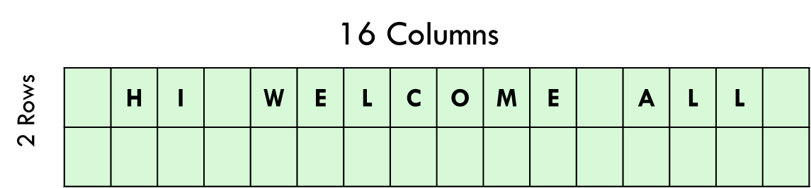

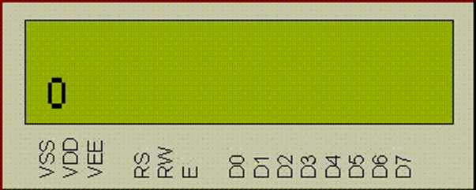

LCD DISPLAY

HARDWARE IMPLEMENTATION

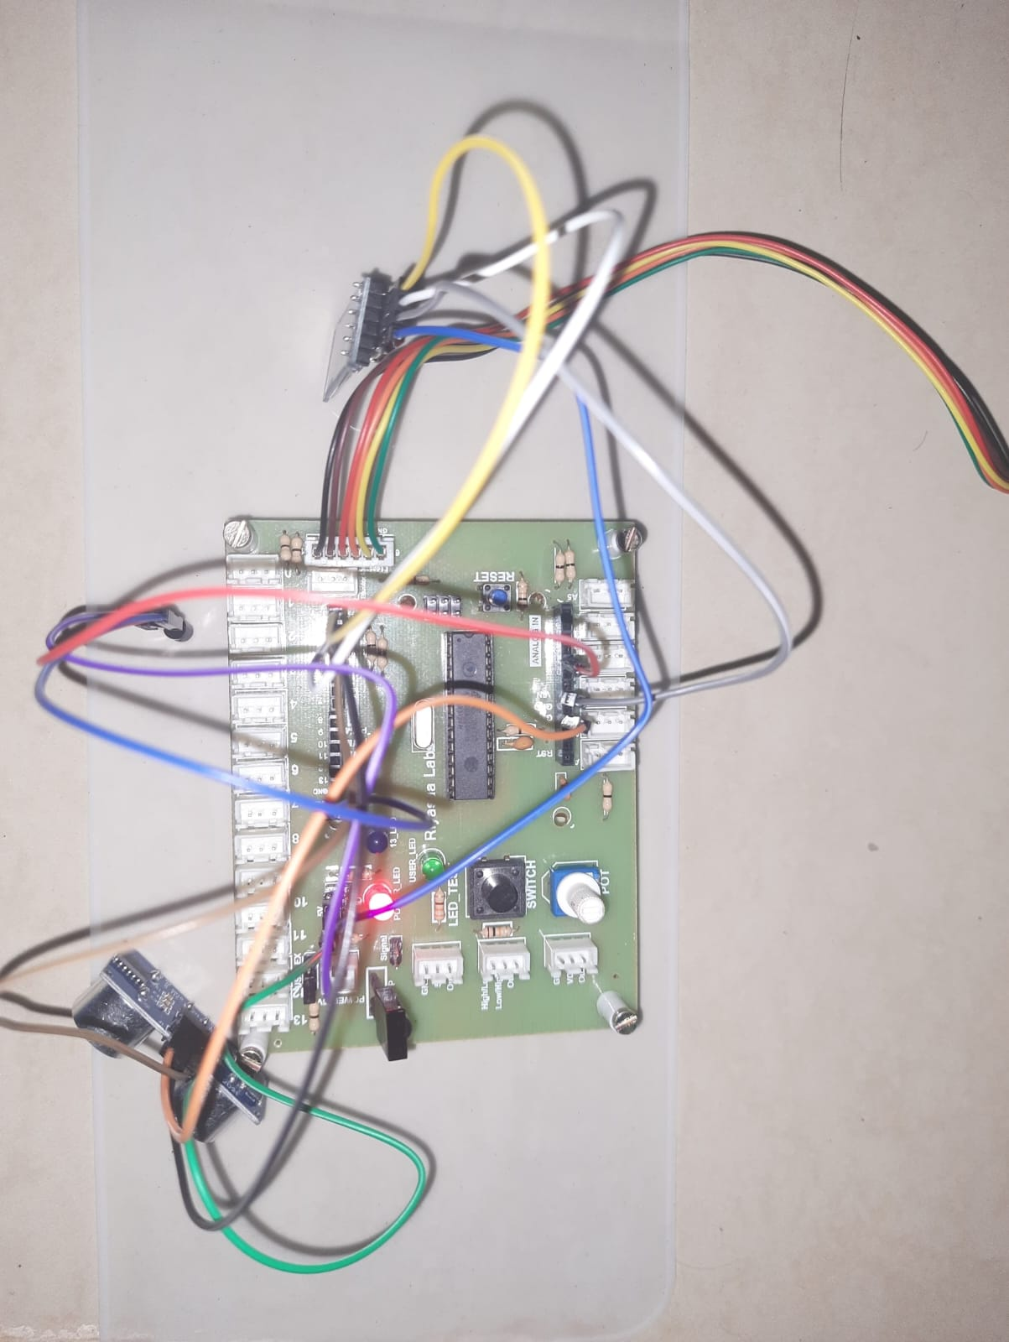

**CHAPTER 6**

**SOFTWARE REQUIREMENT**

**EMBEDDED C**

Embedded C in IoT (Internet of Things) refers to the use of the C programming language for developing software that runs on embedded systems within IoT devices. IoT encompasses a wide range of interconnected devices that communicate with each other to collect, transmit, and process data. These devices often have limited resources, such as memory and processing power, making it essential to use efficient and optimized programming languages like C.

1. Resource Efficiency:

- IoT devices typically have constrained resources in terms of memory, processing power, and energy consumption. Embedded C is well-suited for such environments as it allows for fine-grained control over system resources.

2. Portability:

- C is a highly portable language, meaning that code written in C can be easily moved from one platform to another with minimal modification. This is crucial in the diverse and evolving landscape of IoT devices, where different manufacturers produce devices with varying architectures.

3. Low-Level Programming:

- Embedded C allows for low-level programming, enabling developers to directly interact with hardware components. This is important in IoT applications where direct control over peripherals and sensors is often required.

4. Real-time Capabilities:

- Many IoT applications involve real-time processing and control. C, with its support for low-level hardware access and deterministic behavior, is well-suited for developing real-time applications.

5. System-level Programming:

- Embedded C allows for system-level programming, enabling developers to manage and control the entire system. This is critical in IoT, where the integration of hardware and software components is key to achieving optimal performance.

6. IoT Protocols:

- IoT devices often communicate using various protocols such as MQTT, CoAP, and HTTP. Embedded C can be used to implement these communication protocols efficiently, ensuring effective data exchange between devices.

7. Security:

- Security is a paramount concern in IoT, and C provides the flexibility to implement robust security features. However, developers need to be mindful of potential security vulnerabilities associated with manual memory management in C.

**Summary**

Embedded C is a popular choice for IoT development due to its efficiency, portability, low-level capabilities, and suitability for resource-constrained environments. Developers working on IoT projects often use C to create firmware and software that enables IoT devices to perform their intended functions reliably and efficiently.

**CHAPTER 7**

**EXPERIMENTAL ANALYSIS AND RESULT**

**INTRODUCTION**

The workload of medical staff can be greatly reduced by the IoT-based monitoring system. Medical staff can concentrate on other facets of patient care, such as diagnosis and treatment, by automating the monitoring process. In order to help the medical personnel make educated decisions about the patient's treatment, the system can also give them realtime access to the patient's vital indicators. The monitoring system built on the Internet of Things can also greatly lessen the strain of the medical team. The monitoring procedure can be automated so that medical personnel can concentrate on other areas of patient care, such diagnosis and treatment. The technology can also give medical professionals real-time access to the patient's vital signs, enabling them to decide on the patient's care with knowledge.

**HARDWARE REPRESENTATION**



# **OUTPUT**

The graphical representation of information of the patient which means exactly health status is established i.e. body temperature, blood pressure are as showed up in the fig-6 which is observed by signing into the Thing speak server through a personal computer which has Date in x- axis and the parameter in y-axis. If there is any changes occur in body position, eye movement and urine level of comatose then an alert SMS is send to the doctor or any medical person with the help of Twilio. Fig-7 shows the different alert sms received by doctor. So it is very useful for patient's to give first aid at any time and to report a clear notification of patient database health status in graphical form.

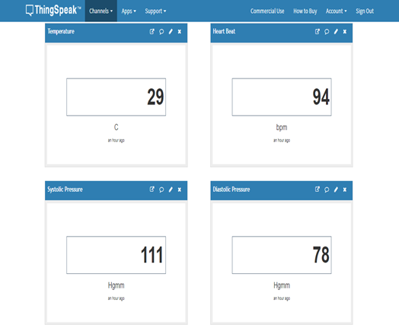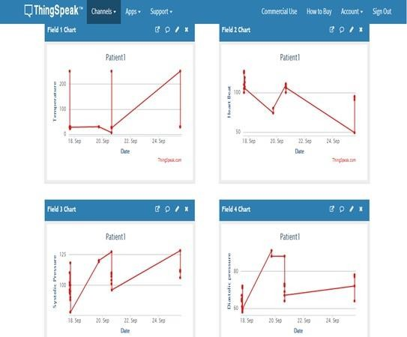

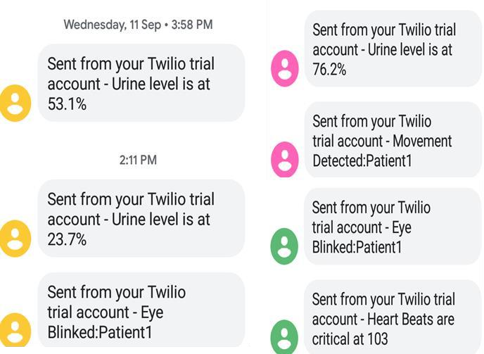

**Screenshots of Alert SMS**

**CHAPTER 8**

**CONCLUSION AND FUTURE WORK**

**CONCLUSION**

In conclusion, an Internet of Things (I OT)-based monitoring system for unconscious patients may offer a creative way to continuously monitor vital signs. The system can be created to gather data from multiple sensors and send it to a cloudbased platform for archiving and analysis by using Arduino Uno as the microcontroller. The technology has the potential to increase healthcare efficiency and enable early diagnosis of health conditions, despite security, privacy, and regulatory compliance issues that must be taken into account. Overall, this technology has a great deal of potential to change the healthcare landscape and enhance patient outcomes.

**FUTURE ENHANCEMENT**

Miniaturization and Wearable Devices: Move towards smaller, more wearable sensor designs to enhance comfort and portability for patients. Miniaturized sensors can facilitate continuous monitoring without causing discomfort or hindering daily activities.Real-Time Alerts and Predictive Analysis: Introduce real-time alert systems based on sensor data analysis. Incorporate predictive analytics to anticipate health-related incidents or deteriorations, enabling proactive intervention by healthcare providers.Cloud Integration and Big Data Analysis: Utilize cloud-based platforms to store and analyze vast amounts of health data collected by the sensors. Implement big data analytics to derive meaningful insights, trends, and correlations that could aid in more accurate diagnoses and treatment plans.Biometric Authentication and Privacy Features: Integrate biometric authentication for secure access to patient data on the monitoring system. Implement stringent privacy measures to ensure compliance with healthcare regulations and protect sensitive patient information.AI-Driven Diagnostics and Decision Support: Explore artificial intelligence (AI) algorithms for diagnosing health conditions or providing decision support based on sensor data. AI models can assist healthcare professionals in making informed decisions regarding patient care.These enhancements can transform the COMOTOSR health monitoring system into a more sophisticated, proactive, and comprehensive platform, catering to diverse healthcare needs and promoting a higher standard of patient care and well-being

**REFERANCE**

[1]Pingky Krisna Arindra, "Vital Sign - Tekanan Darah, Nadi, Respirasi, dan Suhu - Bedah Mulut dan Maksilofesial." [Online].

Available: http://ibmm.fkg.ugm.ac.id/?p=704. [Accessed: 25-Sep2018],

[2] M. Gaeeni, M. A. Farahani, N. Seyedfatemi, and N. Mohammadi, "Informational Support to Family Members of Intensive Care Unit Patients: The Perspectives of Families and Nurses," Glob. J. Health Sci., vol. 7, no. 2, p. p8, Sep. 2014.

[3] K. Obringer, C. Hilgenberg, and K. Booker, "Needs of adult family members of intensive care unit patients," J. Clin. Nurs., vol. 21, no. 11-12, pp. 1651-1658, Jun. 2012.

[4] P. Bijttebier, D. Delva, S. Vanoost, H. Bobbaers, P. Lauwers, and H. Vertommen, "Reliability and validity of the Critical Care Family Needs Inventory in a Dutch-speaking Belgian sample," 2000.

[5] A. Rippin, "SECOND THOUGHTS Evidence-Based Design: Structuring Patient-and Family-Centered ICU Care," 2016.

[6] N. H. B. A. Bakar, K. Abdullah, and M. R. Islam, "Wireless Smart Health Monitoring System via Mobile Phone," 2016 Int. Conf. Comput. Commun. Eng., pp. 213-218, 2016.

[7] Z. Ali, G. Muhammad, and M. F. Alhamid, "SPECIAL SECTION ON ADVANCES OF MULTISENSORY SERVICES AND An Automatic Health Monitoring System for Patients Suffering From Voice Complications in Smart Cities," vol. 5, pp. 19835-19841, 2017. [8] D. J. Freitas, T. B. Marcondes, L. H. V. Nakamura, and R. I. Meneguette, "A health smart home system to report incidents for disabled people," Proc. - IEEE Int. Conf. Distrib. Comput. Sens. Syst. DCOSS 2015, pp. 210-211,2015.

[9] E. Ding et al., "Impressions of Older Patients with Cardiovascular Diseases to Smart Devices for Heart Rhythm Monitoring," 2017 IEEE/ACM Int. Conf. Connect. Heal. Appl. Syst. Eng. Technol., pp. 270-271,2017.

[10] M. H. Alsulami, A. S. Atkins, and R. J. Campion, "The use of smart watches to monitor heart rates in elderly people: A complementary approach," Proc. IEEE/ACS Int. Conf. Comput. Syst. Appl. AICCSA, 2017.

[11] A. A. Alian and K. H. Shelley, "Photoplethysmography," Best Pract. Res. Clin. Anaesthesiol., vol. 28, no. 4, pp. 395^06,2014

**SOURCE CODE**

#include <PulseSensorPlayground.h>

#include <OneWire.h>

#include <DallasTemperature.h>

#include <SoftwareSerial>

#include <LiquidCrystal.h> // Include the LCD library

LiquidCrystal lcd(8, 9, 10, 11, 12, 13); // Define the pins for your LCD

const int pulseSensorPin = A0; // Analog input connected to the pulse sensor

PulseSensorPlayground pulseSensor;

const int triggerPin = 9; // Digital pin connected to the ultrasonic sensor's trigger

const int echoPin = 10; // Digital pin connected to the ultrasonic sensor's echo

OneWire oneWire(2); // Digital pin connected to the DS18B20 temperature sensor

DallasTemperature sensors(&oneWire);

int eyeBlinkPin = 5; // Digital input pin connected to the eyeblink sensor

SoftwareSerial bluetooth(3, 4); // RX, TX pins for the HC-05 module

void setup() {

Serial.begin(9600);

bluetooth.begin(9600);

pulseSensor.analogInput(pulseSensorPin);

pulseSensor.setSerial(Serial);

pinMode(triggerPin, OUTPUT);

pinMode(echoPin, INPUT);

pinMode(eyeBlinkPin, INPUT);

sensors.begin();

// Initialize the LCD

lcd.begin(16, 2);

}

void loop() {

// Ultrasonic Sensor

long duration;

int distance;

digitalWrite(triggerPin, LOW);

delayMicroseconds(2);

digitalWrite(triggerPin, HIGH);

delayMicroseconds(10);

digitalWrite(triggerPin, LOW);

duration = pulseIn(echoPin, HIGH);

distance = duration * 0.034 / 2;

lcd.setCursor(0, 0);

lcd.print("Distance: " + String(distance) + " cm");

Serial.print("Distance: ");

Serial.print(distance);

Serial.println(" cm");

bluetooth.print("Distance: ");

bluetooth.print(distance);

bluetooth.println(" cm");

// Infrared Temperature Sensor

sensors.requestTemperatures();

float temperatureC = sensors.getTempCByIndex(0);

float temperatureF = sensors.getTempFByIndex(0);

lcd.setCursor(0, 1);

lcd.print("Temp: " + String(temperatureC) + "C " + String(temperatureF) + "F");

Serial.print("Temperature: ");

Serial.print(temperatureC);

Serial.print("°C / ");

Serial.print(temperatureF);

Serial.println("°F");

bluetooth.print("Temperature: ");

bluetooth.print(temperatureC);

bluetooth.print("°C / ");

bluetooth.print(temperatureF);

bluetooth.println("°F");

// Pulse Sensor

int heartRate = pulseSensor.getBeatsPerMinute();

if (pulseSensor.sawStartOfBeat()) {

lcd.setCursor(0, 2);

lcd.print("HR: " + String(heartRate) + " BPM");

Serial.print("Heart Rate: ");

Serial.println(heartRate);

bluetooth.print("Heart Rate: ");

bluetooth.println(heartRate);

}

// Eyeblink Sensor

int eyeBlinkState = digitalRead(eyeBlinkPin);

if (eyeBlinkState == HIGH) {

lcd.setCursor(0, 3);

lcd.print("Eye Blink Detected");

Serial.println("Eye Blink Detected");

bluetooth.println("Eye Blink Detected");

} else {

lcd.setCursor(0, 3);

lcd.print("Eye Blink Not Detected");

}

// You can add more code here to process the sensor data.

delay(1000); // Delay between sensor readings